Docker swarm

1.setup server 3 ubuntu

2,install docker all server

3. docker swarm init in master& get token

and shared to node1 & 2

4. add new node 3 attched to docker swarm

5. every command run only master node

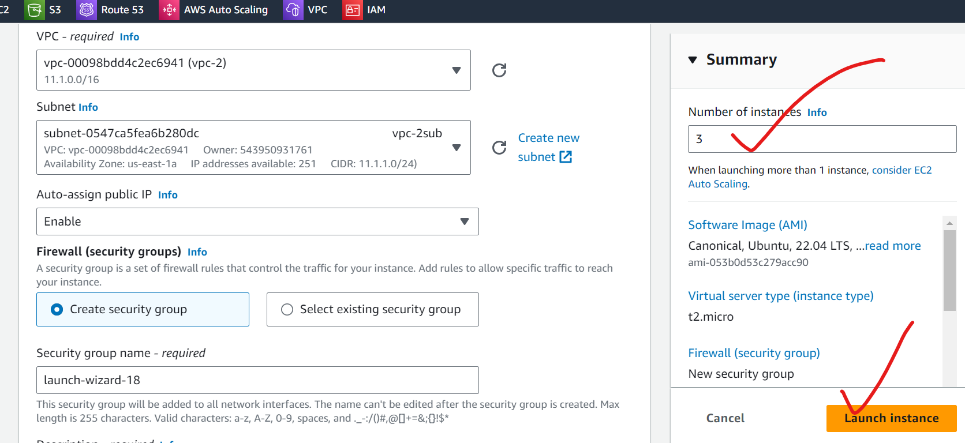

3 server by same vpc

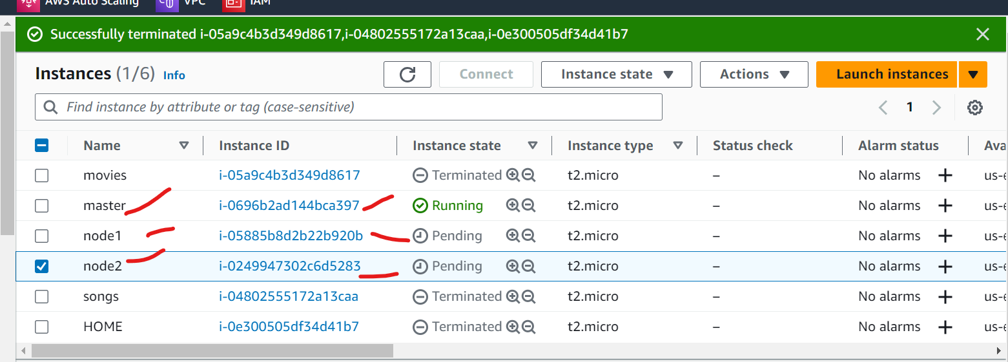

Give tage

1 master

2 node 1

3. node3

3 step

Docker swarm inti in master

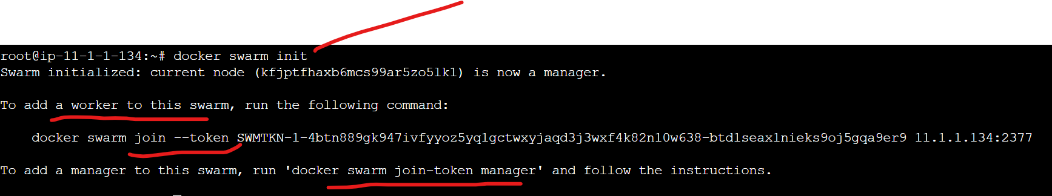

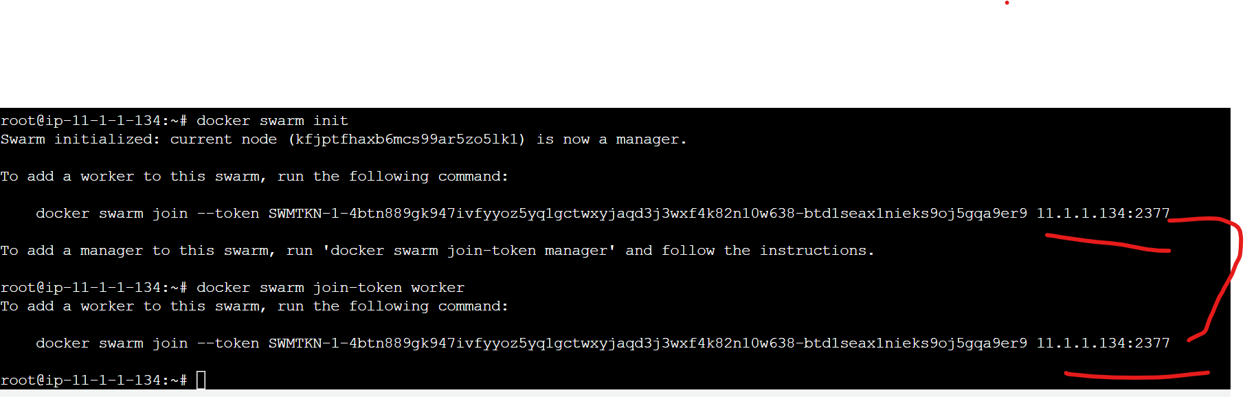

Added tocken to node1 & node2

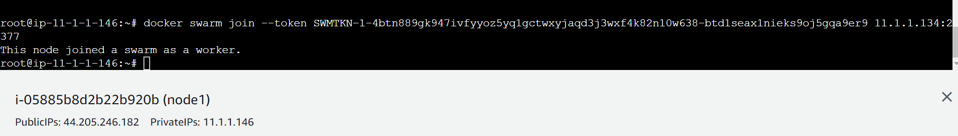

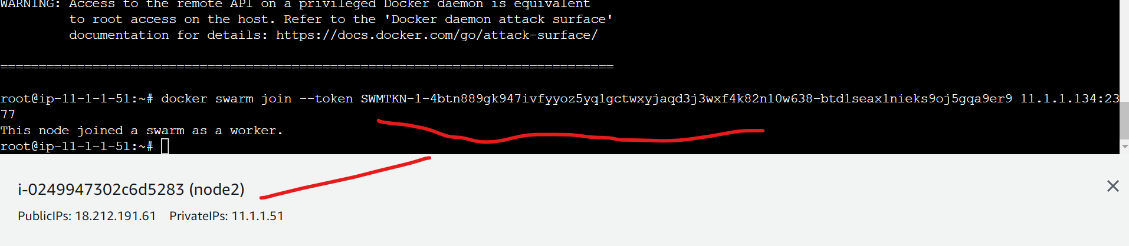

Docker node ls

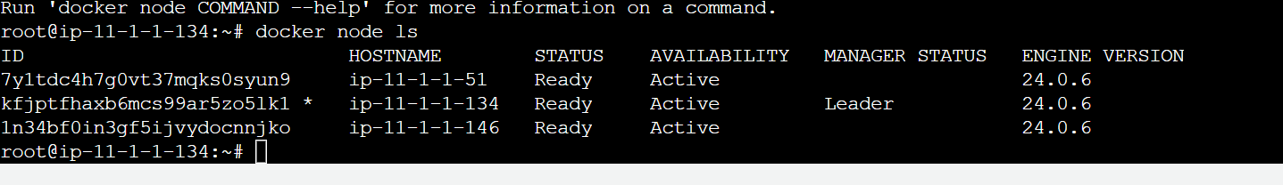

Step 4 create new server and install docker & docker swarm tocker shared to new server

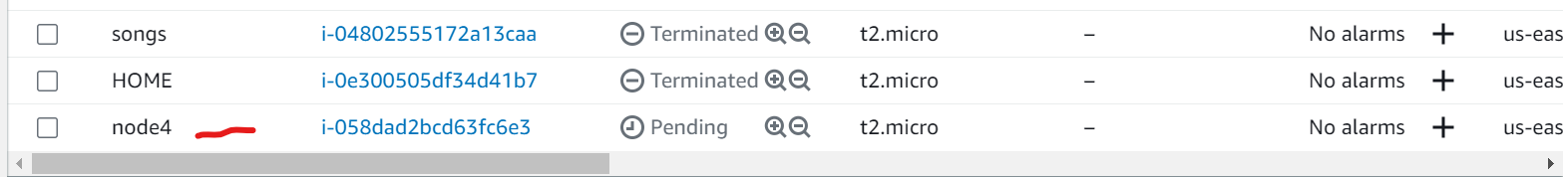

Creating

Add node tocken to node4 server

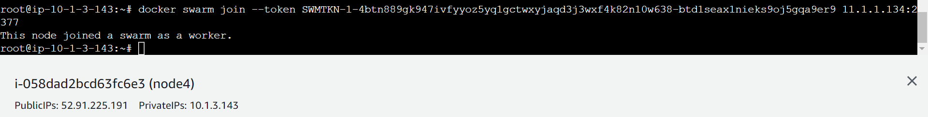

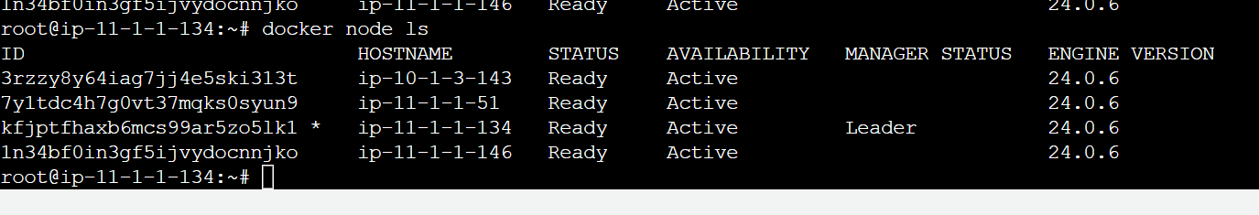

Check ifconfig

root@ip-11-1-1-134:~# apt install net-tools

root@ip-11-1-1-134:~# ifconfig

docker0: flags=4099<UP,BROADCAST,MULTICAST> mtu 1500

inet 172.17.0.1 netmask 255.255.0.0 broadcast 172.17.255.255

ether 02:42:64:6e:61:26 txqueuelen 0 (Ethernet)

RX packets 0 bytes 0 (0.0 B)

RX errors 0 dropped 0 overruns 0 frame 0

TX packets 0 bytes 0 (0.0 B)

TX errors 0 dropped 0 overruns 0 carrier 0 collisions 0

docker_gwbridge: flags=4163<UP,BROADCAST,RUNNING,MULTICAST> mtu 1500

inet 172.18.0.1 netmask 255.255.0.0 broadcast 172.18.255.255

inet6 fe80::42:76ff:fead:37a0 prefixlen 64 scopeid 0x20<link>

ether 02:42:76:ad:37:a0 txqueuelen 0 (Ethernet)

RX packets 0 bytes 0 (0.0 B)

RX errors 0 dropped 0 overruns 0 frame 0

TX packets 8 bytes 800 (800.0 B)

TX errors 0 dropped 0 overruns 0 carrier 0 collisions 0

eth0: flags=4163<UP,BROADCAST,RUNNING,MULTICAST> mtu 9001

inet 11.1.1.134 netmask 255.255.255.0 broadcast 11.1.1.255

inet6 fe80::1013:6eff:feaa:a8af prefixlen 64 scopeid 0x20<link>

ether 12:13:6e:aa:a8:af txqueuelen 1000 (Ethernet)

RX packets 108756 bytes 149168049 (149.1 MB)

RX errors 0 dropped 0 overruns 0 frame 0

TX packets 10975 bytes 1162682 (1.1 MB)

TX errors 0 dropped 0 overruns 0 carrier 0 collisions 0

lo: flags=73<UP,LOOPBACK,RUNNING> mtu 65536

inet 127.0.0.1 netmask 255.0.0.0

inet6 ::1 prefixlen 128 scopeid 0x10<host>

loop txqueuelen 1000 (Local Loopback)

RX packets 284 bytes 35492 (35.4 KB)

RX errors 0 dropped 0 overruns 0 frame 0

TX packets 284 bytes 35492 (35.4 KB)

TX errors 0 dropped 0 overruns 0 carrier 0 collisions 0

vethefb65be: flags=4163<UP,BROADCAST,RUNNING,MULTICAST> mtu 1500

inet6 fe80::68f1:5aff:fea4:5168 prefixlen 64 scopeid 0x20<link>

ether 6a:f1:5a:a4:51:68 txqueuelen 0 (Ethernet)

RX packets 0 bytes 0 (0.0 B)

RX errors 0 dropped 0 overruns 0 frame 0

TX packets 20 bytes 1696 (1.6 KB)

TX errors 0 dropped 0 overruns 0 carrier 0 collisions 0

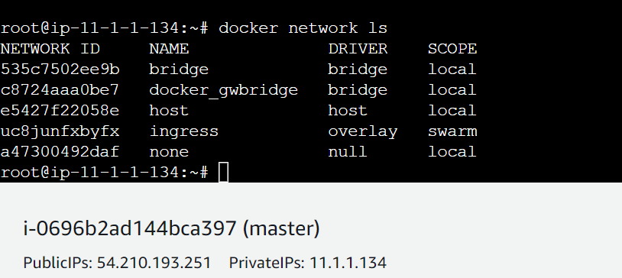

Check nwtwork master node

Wt is overley & bridge n/w

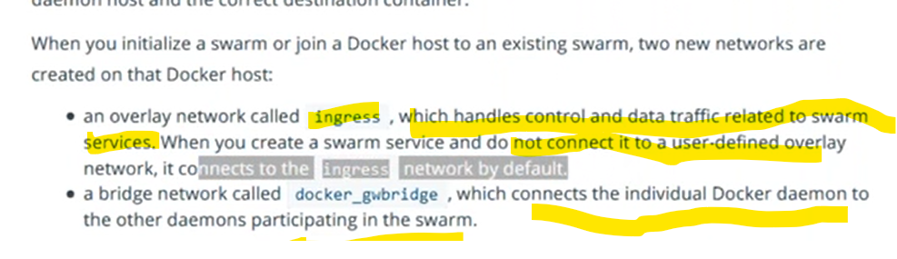

Example docker0 n/w

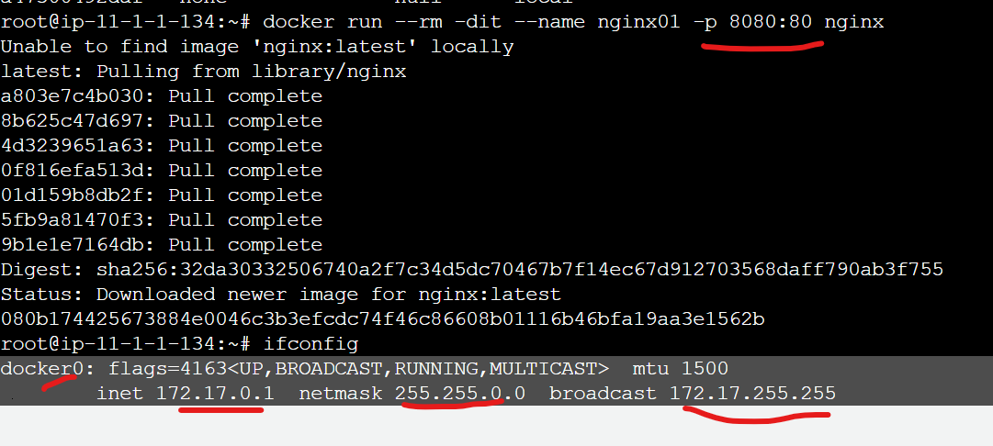above container ruuning by docker 0 n/w

Docker run –rm -dit –name nginx01 -p 8080:80 nginx



root@ip-11-1-1-134:~# docker inspect 080b17442567

above check the ip of conatiner

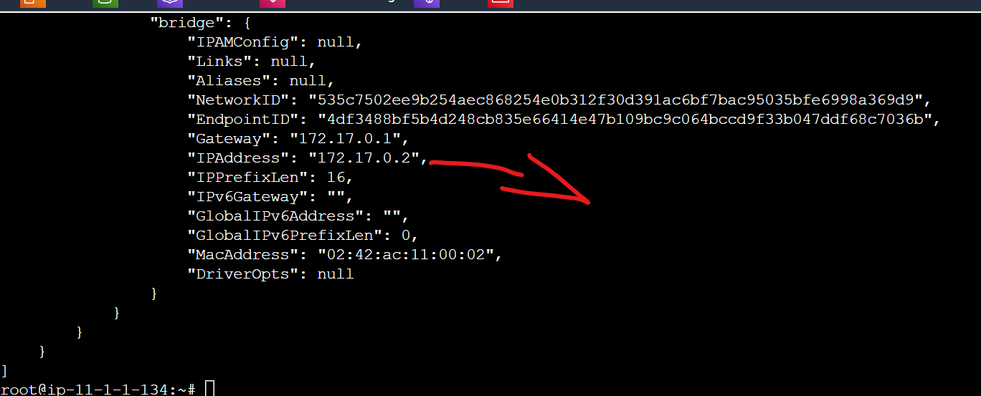

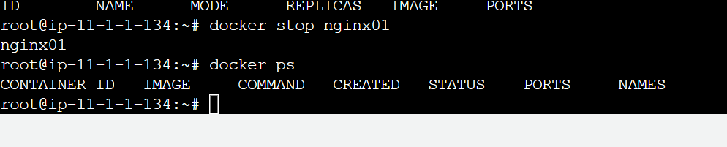

Above we are stop container let me do in swarm

Check the images in swarm

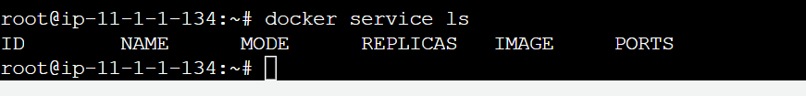

Wt Is gateway bridge

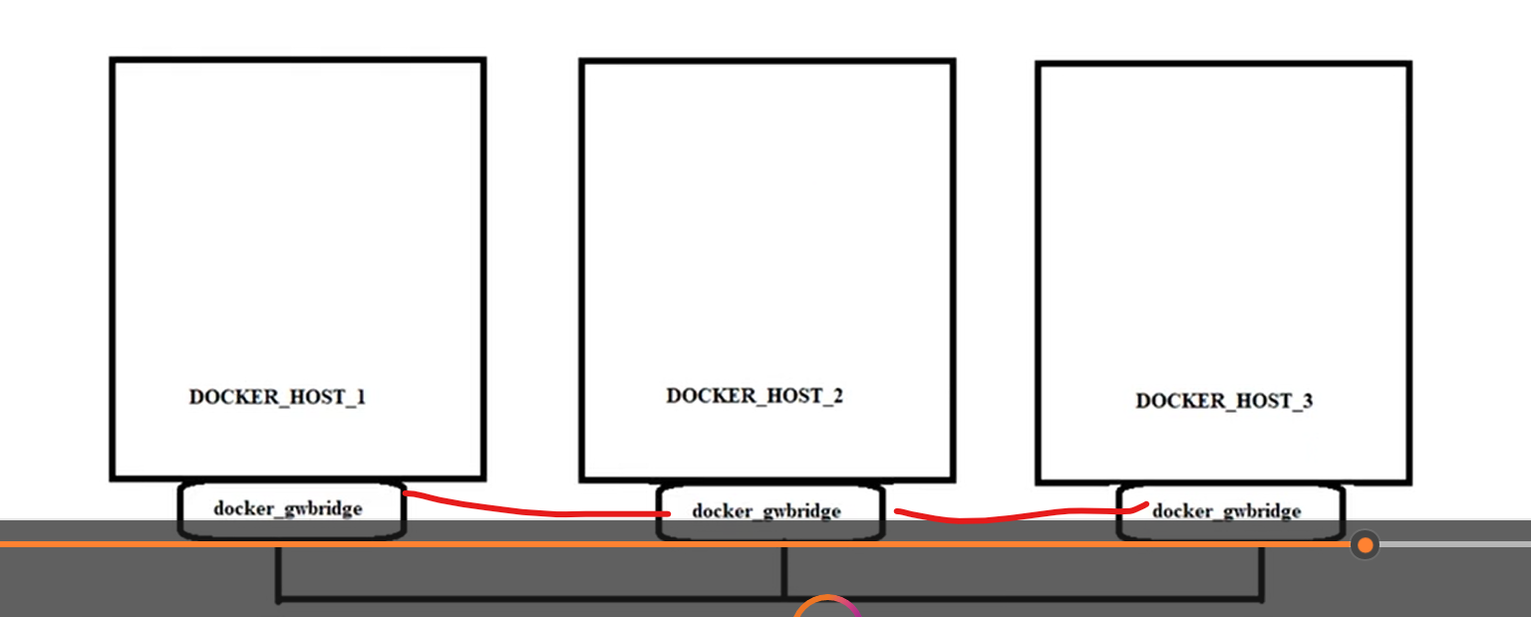

How to create new n/w in docker swarm?

root@ip-11-1-1-134:~# docker network create frontend -d overlay

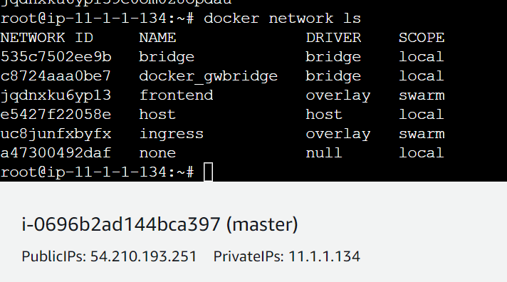

Create replicas in docker swarm use below commad

root@ip-11-1-1-134:~# docker service create --name testing1 --replicas 3 --network frontend --publish 8000:80 nginx

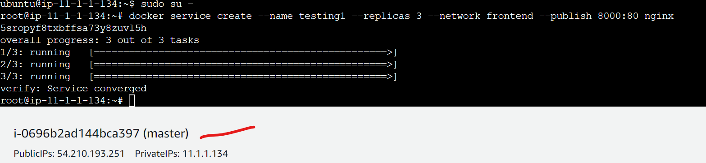

Check running container

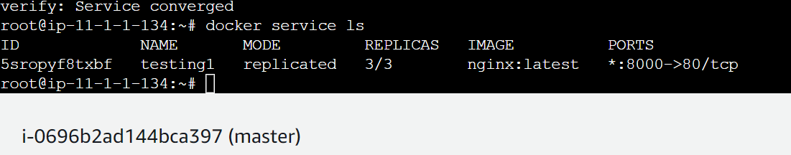



Increasing replicas

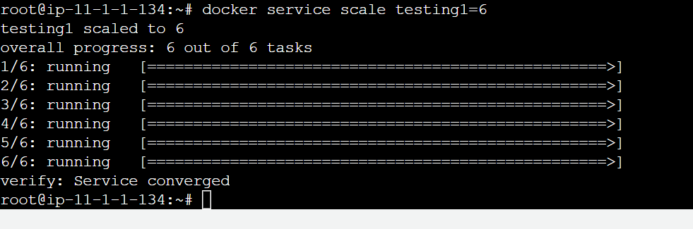

root@ip-11-1-1-134:~# docker service scale testing1=6

check all contaoiner

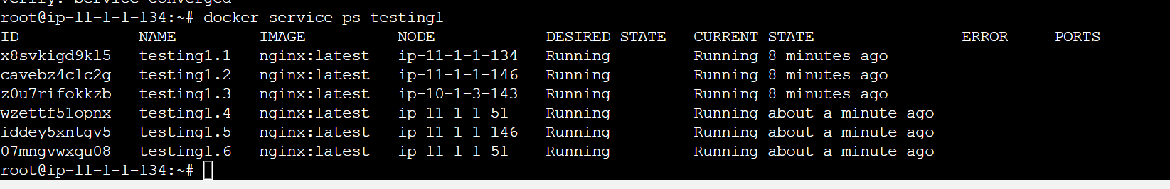

docker run -it -d -p 8080:8080 -v /var/run/docker.sock:/var/run/docker.sock dockersamples/visualizer

<https://github.com/dockersamples/docker-swarm-visualizer>

click above link check above command &run in master server

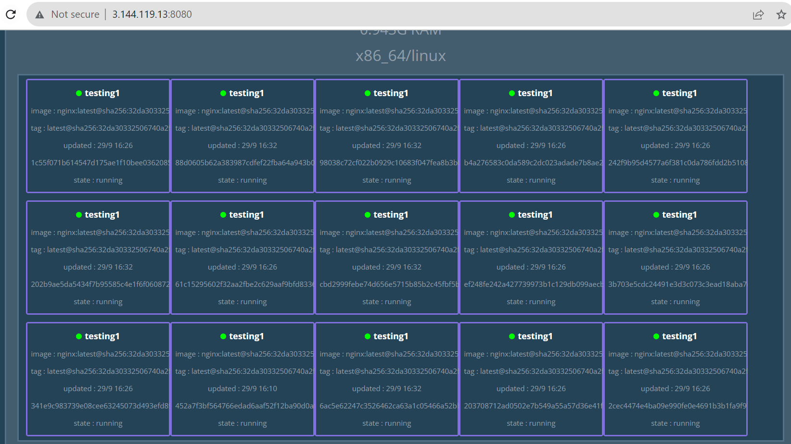

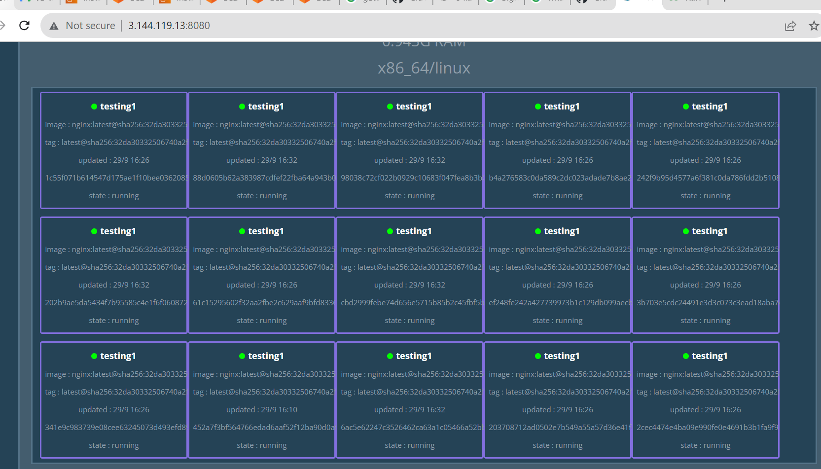

Node availbilty:

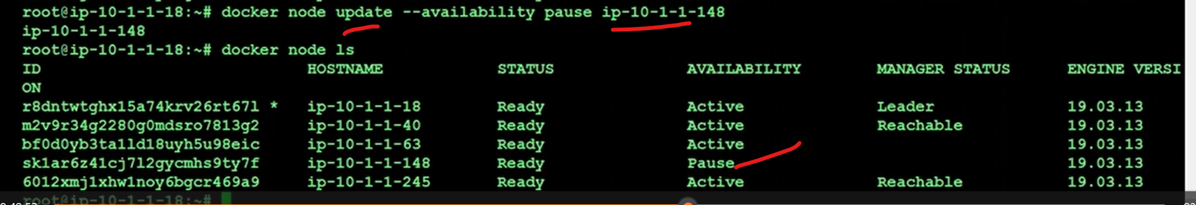

Docker life cycle policy

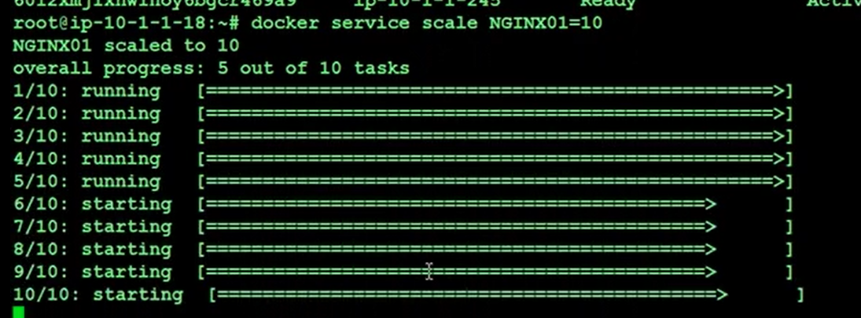

If u scale up more replicacas but pause node not accept fro the new container

Now drain lifecycle

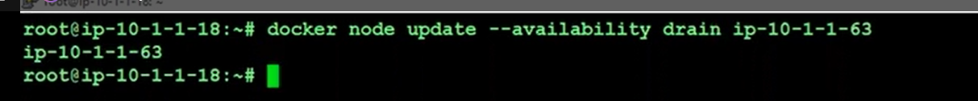

Now completely remove pods from node

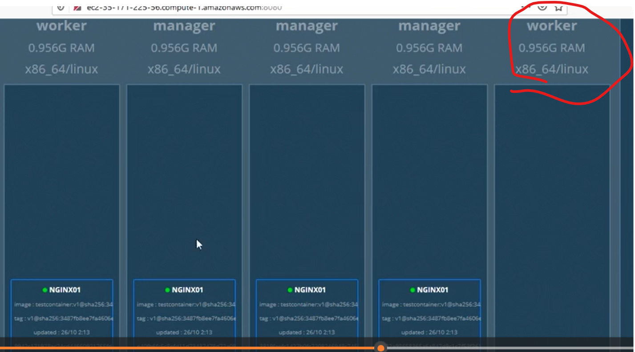

Active life cycle:

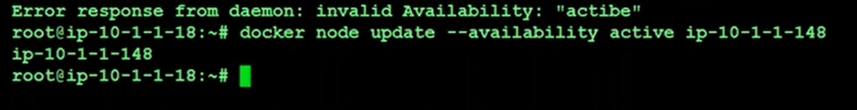

Add new after active lifrcycle

